## Robot Requirements:

1. **On the spot turning**
2. **Independent wheel control to avoid building**
3. **Wireless communication ability to talk to the server**
4. **Local position tracking enabling robot side position tracking**

**Class Diagram**

## Position Tracking:

1. **Dead reckoning is used by the motors to track position and heading.**
2. **As the games progress compound errors are introduced**
3. **These errors are corrected by using the grid to tell the robot where it is.**
4. **When the robot “sees” a dot it references the nearest point on its internal map representation and snaps the robot location to that point.**

## NXT MindStorms:

1. 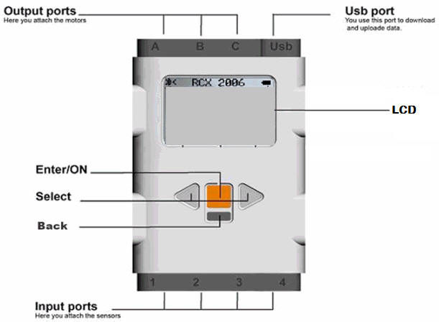**Highly programmable and customizable microcontroller system**
2. **Supports up to 7 peripherals, including color, ultraviolet and touch sensors**
3. **48Mhz Microprocessor with 64KB RAM**
4. **Supports Bluetooth 2.1 and USB 2.0**

## RoboWars Robots:

1. 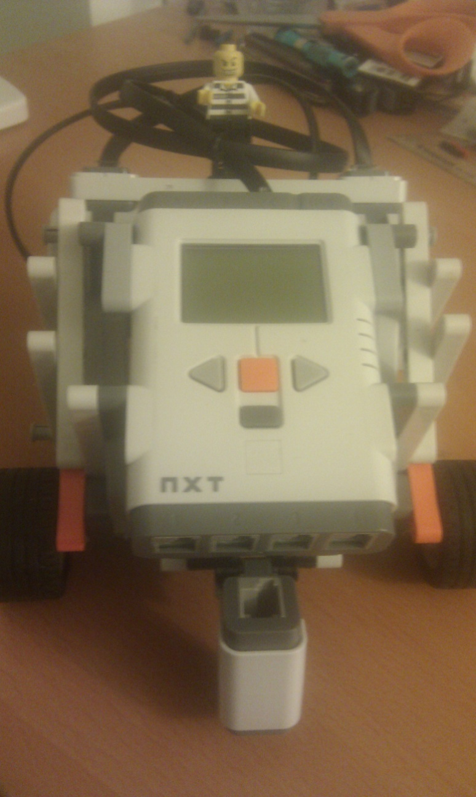**Tripod, dual engine with a central support/steering column**
2. **Front mounted 8Bit-Color Sensor**
3. **3.3:1 Gear Ratio allowing for up to 594 RPM**
4. **Can communicate over Bluetooth at a range of over 9.1m**

## The Grid:

1. **A series of points which correspond to an (X,Y) co ordinate of the Robot’s internal map**
2. **By using the actual known positions the grid can be used to correct drifts in the robots**
3. **Also makes a great makeshift twister board**